Anstey Hall Hover-in 18th August 2019
The purpose of this document is to outline further particulars of the Anstey Hall Hover-in on the 18th of August 2019. For the complete method statement and risk assessment please see the other documents that make up this pack.
The Hovercraft Club of Great Britain (hereafter referred to as HCGB) has been invited to attend the VNC Automotive Limited Summer Party (event flyer shown below) as a hover-in event to promote the club and the unique sport of hovercraft racing and cruising.

The HCGB is planning to attend the event with at least one hovercraft with a view to giving rides, training novice drivers, and answering questions about the all aspects of hovercraft to promote the club’s activities.
The HCGB is one of several activities that will be attending the event. A diagram showing the layout of the site is given below.
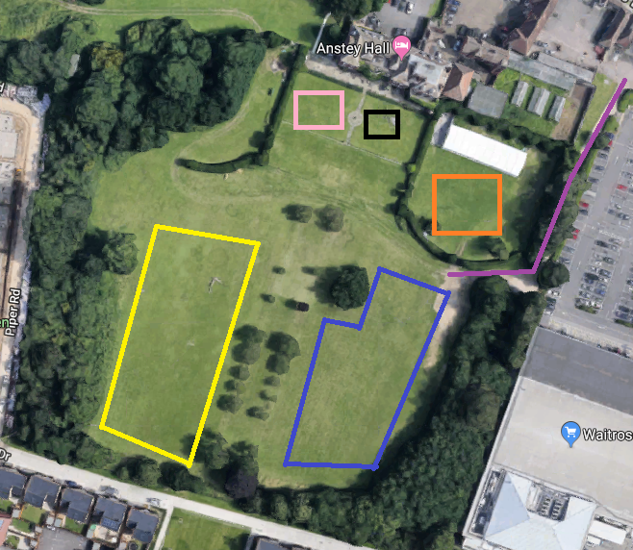
- The Purple line represents the gated access to the event site from the road. The access road is well paved and is also the emergency access rout to the operational area.
- The Yellow box represents the area where the HCGB hover-in will be operating. This area will be clearly marked out using ropes and road pins.
- The Orange box represents where pony rides will be taking place. Note this is screened from the HCGB operating area by a large thick hedge that will muffle the sound of the hover-in as well as screen it from view to avoid alarming the animals.
- The Blue area shows represents Zorbing will be taking place. Note there will be clear separation between the Zorbing and the HCGB operational area demarked by the twin line of trees down the center of the grounds.
- The Black box represents the area for the giant chess set.
- The Pink box represents the area where other assorted family games and activities will be taking place.
- The White Gazebo above the pony area is where food and drink will be provided during the event. Note food and drink is not being provided by the HCGB as part of the hover-in.
- The first Aid station will be within the hall itself.

