Location :
Liverpool Sailing Club
North bank of the River Mersey
Adjacent Garston Coastal reserve and Liverpool John Lennon Airport

Directions :
Speke/Garston Coastal Reserve
Access through barrier on junction of Blackburne Street / Garston Shore Road
Liverpool
Follow track approx. 1.1km (0.68miles) to club entrance

Charges :
Liverpool Sailing Club is a members club run by and for the membership. As such an annual membership fee applies to allow unrestricted access to the slipway. However regular cruise events are held at the club throughout the year whereby craft owners can attend for a nominal fee (usually around £15 - £20 / person which normally includes BBQ Sat night and bacon butties Sunday morning. At organised events the club also opens its bar area and changing room facilities to those attending the cruise

Facilities :
Liverpool Sailing Club is an RYA accredited training facility. The boat yard is gated offering secure parking whilst cruising. There is also the potential for overnight camping at organised events and for sailing club members

Launch access :
The slip way at Liverpool Sailing club consists of a concrete runway of approx. 1000ft in length. Rigging bays offer ample room for unloading and loading of multiple craft. A deep gully to the west of the slip way restricts launching to this side of the slip, however there is a large open expanse of mud to the east which can be traversed down to the main channel.
Due to the tidal nature of the area sandbanks will shift to expose or cover various sections of the slip meaning each launch will potentially be different.
Suitable for self powered launch and recovery at most tide times
Restrictions and permissions :
Speed limits are in place in the area immediately adjacent to the slip due to moorings and other potential launch / recovery operations.
Please note that if heading west out of the river you will enter a busy port area where Notice To Mariner restrictions may be in place. Checks should be made as to these restrictions prior to launch.
Navigational hazards :
Within the main shipping lanes and port access cardinal buoys will identify below surface obstructions.
Due to the tidal nature of the area sand banks and channels will shift. Care should be taken during any operations to ensure safe passage
Cruise area :
The immediate cruise area around the club extends from Garston Docks to the west up to Runcorn Bridge (Jubilee Bridge) to the east giving an area of approx. 25square miles. This area is ideal for those new to cruising or testing minor modifications to a craft before setting off on a longer trip.
Beyond the sand banks to the west of the club is the port of Liverpool with beaches located at Tranmere (pub) Wallasey (pub) and New Brighton (pub) and beyond round to the Dee Estuary. Further restrictions may apply at this point
To the east of the club and beyond the Runcorn Bridge access is possible up to the weir in the centre of Warrington, adjacent to Victoria park and Riverside retail park a distance of approx. 18miles from LSC
Possible Recovery points (road access) :  East of LSC  Victoria Prom (Old Runcorn Bridge)  North Shore  Narrow concrete slip  Accessible most states of the tide  Spike Island  North Shore  Silted up dock gate, will require manhandling  Accessible mid to high tide  Fiddlers Ferry Sailing Club  North Shore  Steep wooden slatted slipway. (Will require access to the club boatyard) Accessible mid to high tide  West of LSC  Coburg Wharf  North Shore  Concrete slip (gated)  Accessible most states of the tide  Rock Ferry Prom (Tranmere Sailing Club)  South Shore  Beach and short concrete slip  Accessible most states of the tide  Monks Ferry  South Shore  Concrete slip. (gated)  Accessible most states of the tide  Egremont Prom  The Ferry  South Shore  Concrete slip (gated)  Accessible most states of the tide  Egremont Prom  Maddock Rd  South Shore  Concrete slip (gated)  Accessible most states of the tide  Egremont Prom  Manor Rd  South Shore  Concrete slip (gated)  Accessible most states of the tide  New Brighton  Black Pearl  South Shore  Concrete Slip (gated)  Accessible most states of the tide  New Brighton  Tower Prom  South Shore  Concrete Slip (gated)  Accessible most states of the tide  New Brighton  Perch Rock  South Shore  Concrete Slip (gated)  Accessible most states of the tide | Approx distance from LSC  12km  (7.6mile)  13.5km (8.3miles)  19.5km  (12miles)  9.4km  (5.8miles)  8.7km  (5.5miles)  10.4km  (6.5miles)  13.5km  (8.6miles)  14.5km  (9.0miles)  14.8km  (9.2miles)  16km  (9.9miles)  16.2km  (10miles)  16.5km  (10.3miles)
Other considerations :
Try to avoid operating in same location for excessive amount of time
Please be considerate of other users at the facility and on the water
Please run craft up and undertake short test run before setting off on longer cruise
Check for any temporary restrictions for access prior to launching
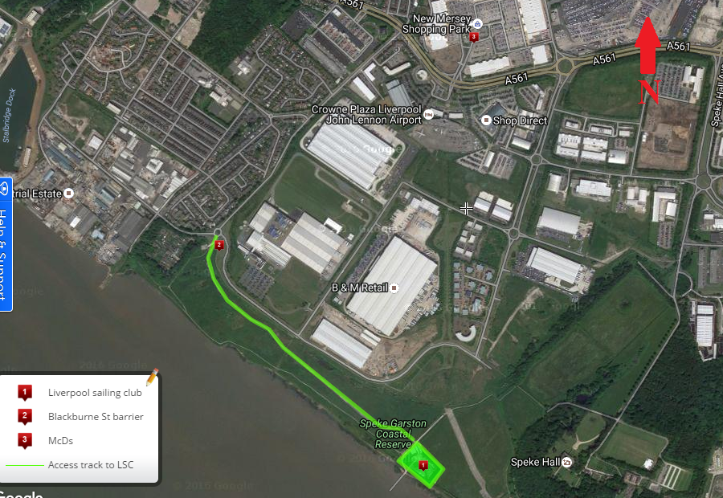
Liverpool Sailing Club location
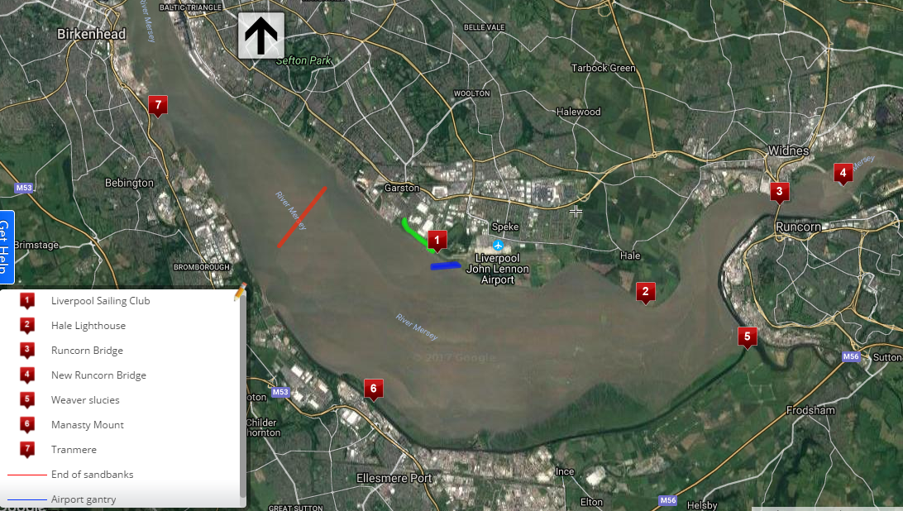
Local cruise area and points of inte

